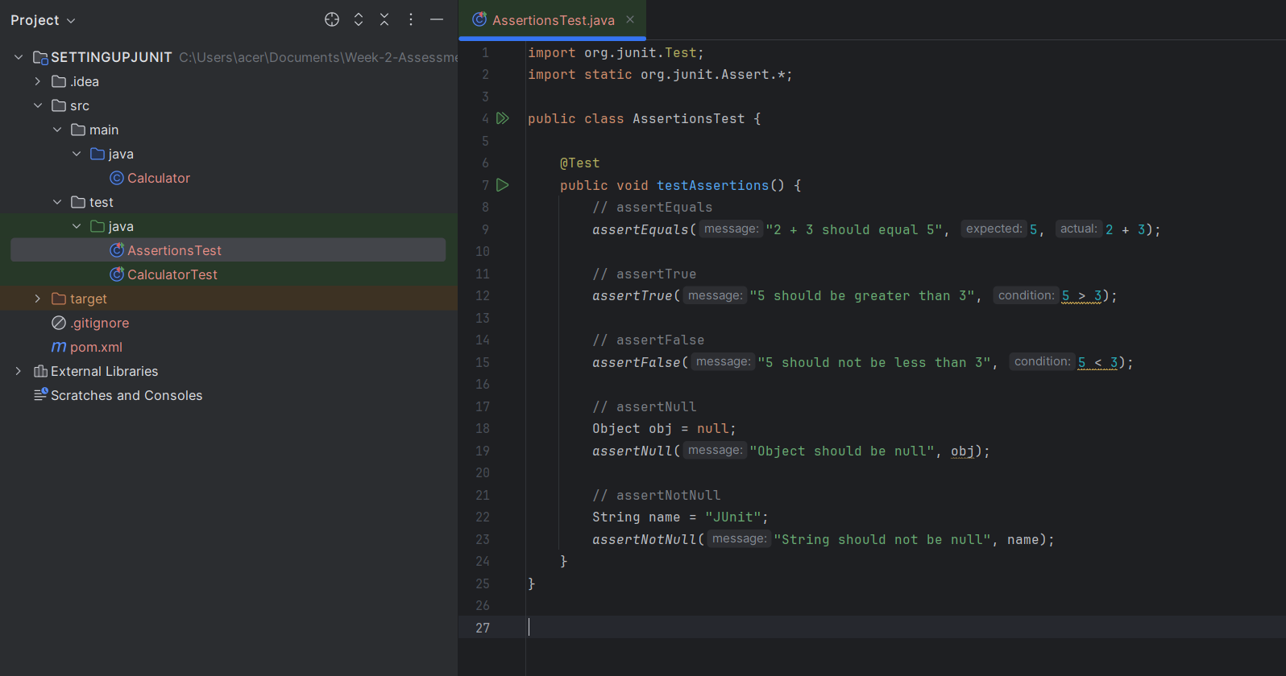

import org.junit.Test;  
import static org.junit.Assert.*;  
  
public class AssertionsTest {  
  
 @Test  
 public void testAssertions() {  
 // assertEquals  
 *assertEquals*("2 + 3 should equal 5", 5, 2 + 3);  
  
 // assertTrue  
 *assertTrue*("5 should be greater than 3", 5 > 3);  
  
 // assertFalse  
 *assertFalse*("5 should not be less than 3", 5 < 3);  
  
 // assertNull  
 Object obj = null;  
 *assertNull*("Object should be null", obj);  
  
 // assertNotNull  
 String name = "JUnit";  
 *assertNotNull*("String should not be null", name);  
 }  
}

**#OUTPUT**

